**Machine Learning Protocol for Breast Cancer**

1. On the lab PC, login and open the application called IDLE (Python 3.8.10 64-bit).
   1. This should be located on the PC’s desktop as a shortcut.

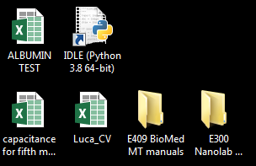

1. Then, click on File → Recent Files. Choose the Python file called svm_breast_cancer.py from the drop-down menu.

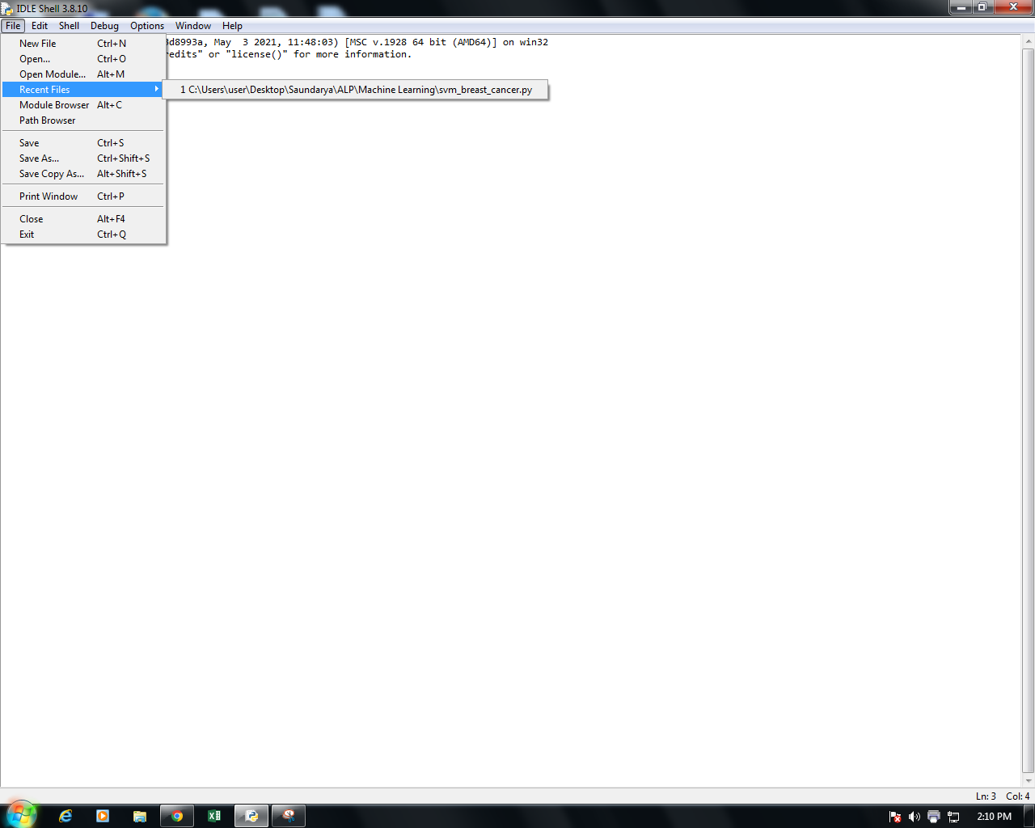

1. After opening svm_breast_cancer.py, click on Run → Run Module at the top of the screen. You can also press F5 on the keyboard to run the program.

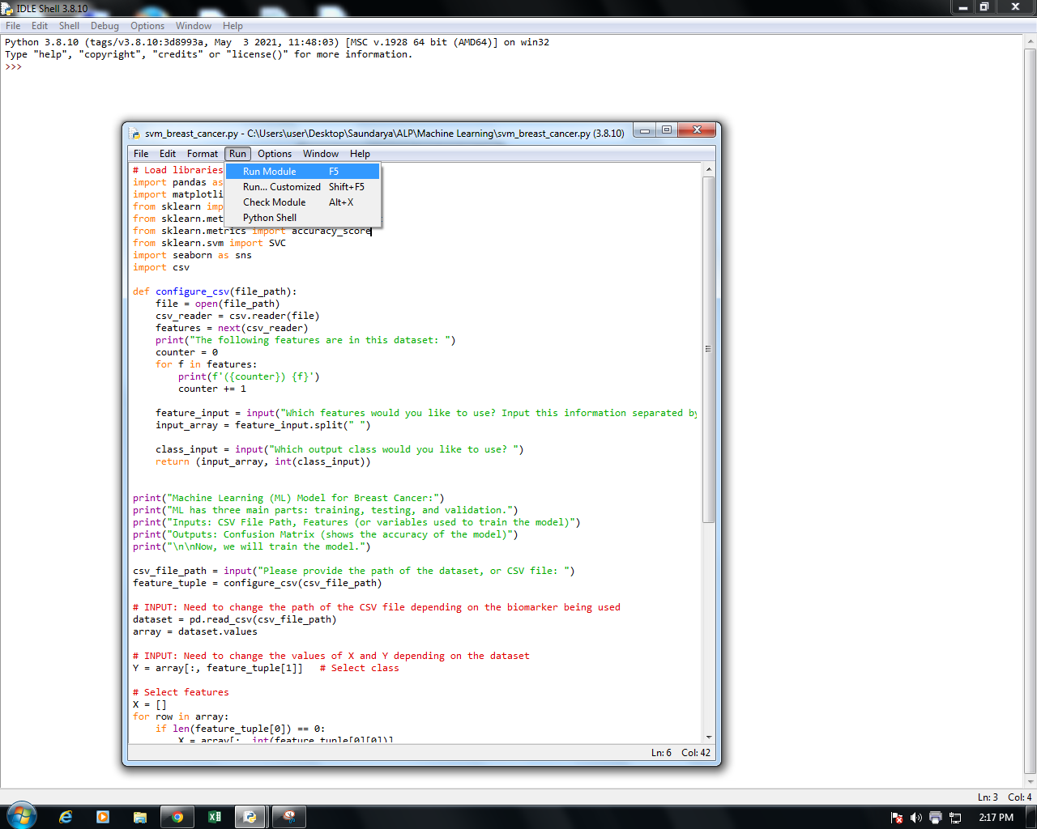

1. Then, the IDLE window should pop up on your screen with a message like **RESTART: C:\Users\user\Desktop\Saundarya\ALP\Machine Learning\svm_breast_cancer.py**.
   1. This means that the Python program has been run by the user.
2. Now, you should see a dialogue asking you to provide the path to the dataset. A **path** describes the location of a file on a computer.

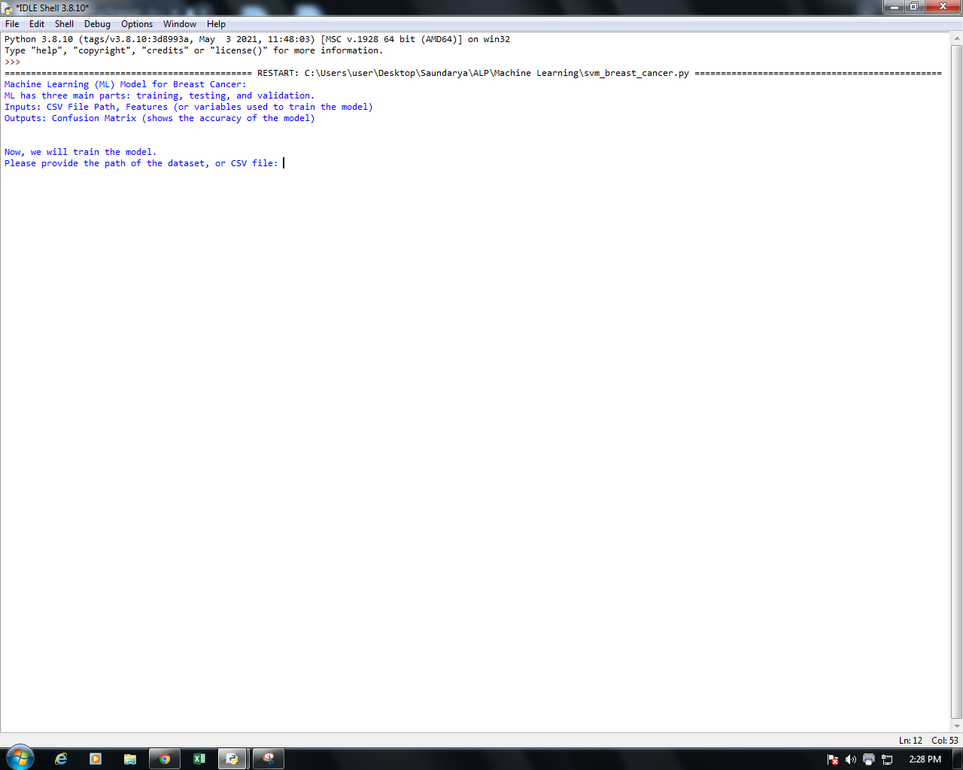

1. To find the path to the dataset, open File Explorer, and find the folder in which the dataset is located. In this case, the dataset is located in a folder called **Machine Learning**.

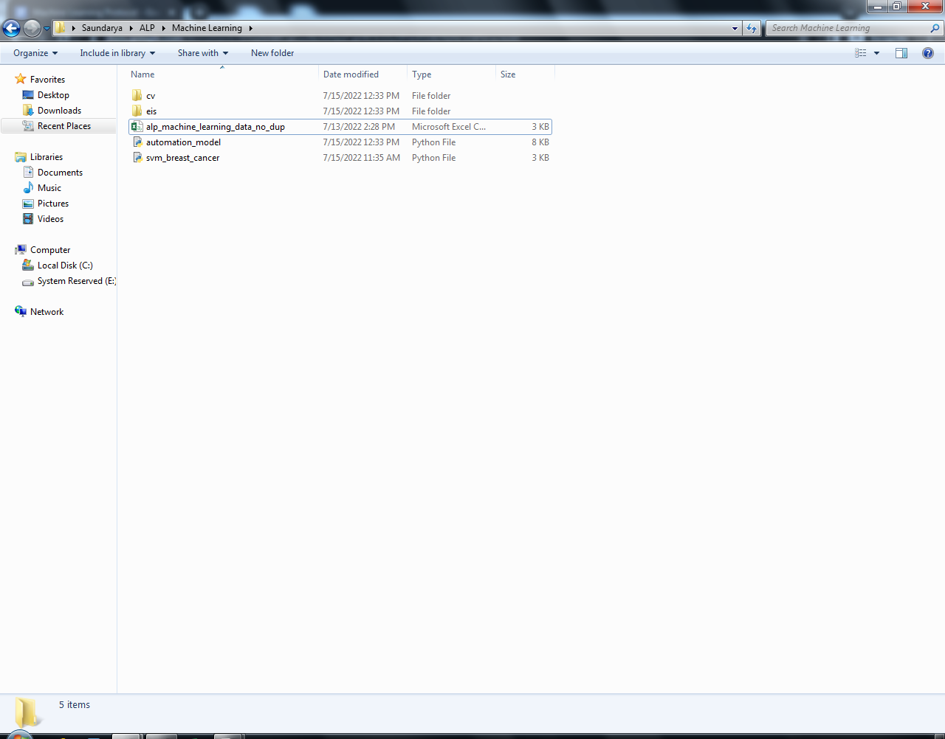

1. In order to get the path to the dataset, press Shift and right-click on the file **at the same time**. In this case, the name of the dataset is alp_machine_learning_data_no_dup.csv.
   1. Then, you should see a field called **Copy as path**. Click on this to copy the path to the file.

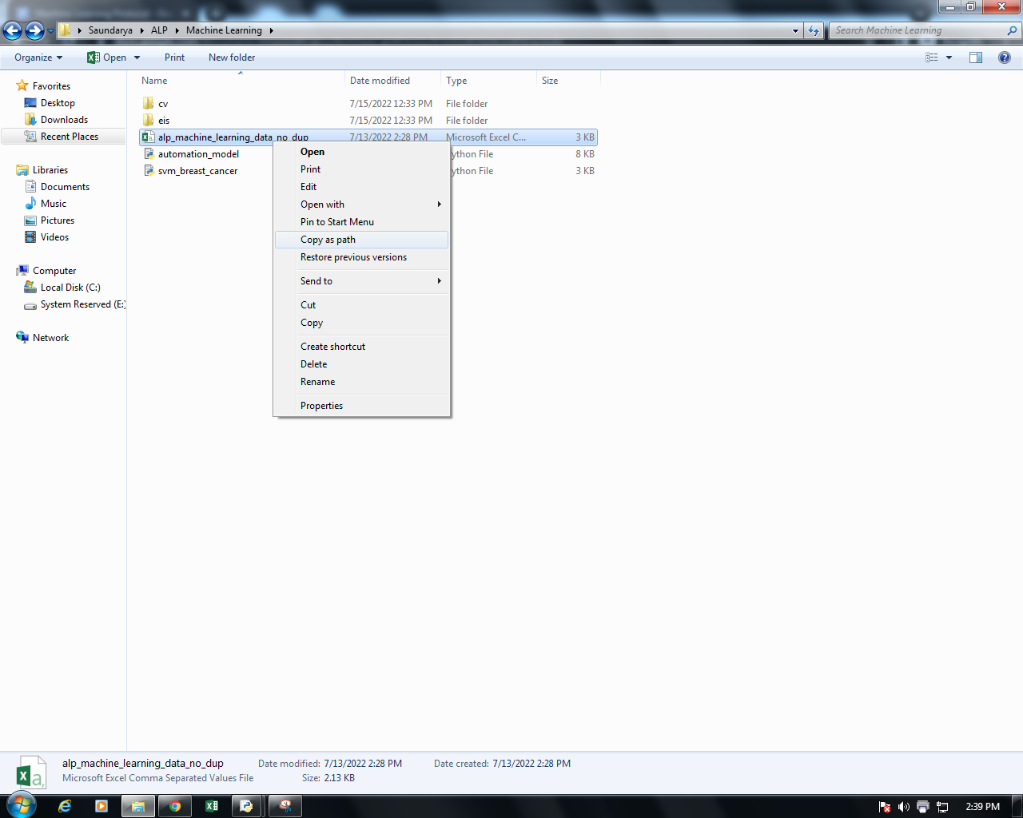

1. Then, navigate to the Python IDLE window and press Ctrl + V to paste the path to the dataset next to the prompt.
   1. After doing so, remove the double quotes at the beginning and end of the path and press Enter. You should see something like this:

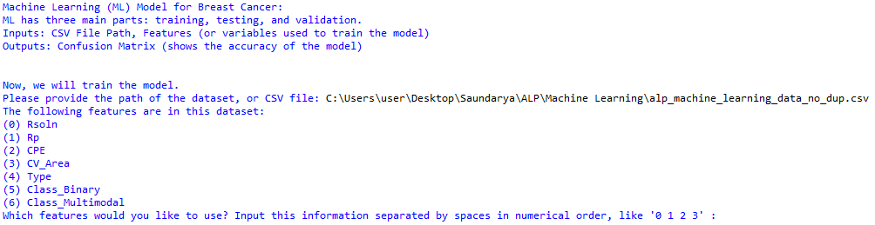

1. Now, select the features that you would like to use. For example, if I want to use Rsoln, Rp, CPE, and CV_Area, I would type **0 1 2 3** at the prompt and press Enter.
2. Then, you should receive a prompt that looks like the following. Now, you need to choose the output class, or the variable you are trying to predict.
   1. If I want to generate a risk profile, I would choose **Class_Multimodal** by typing **6** and then pressing Enter.

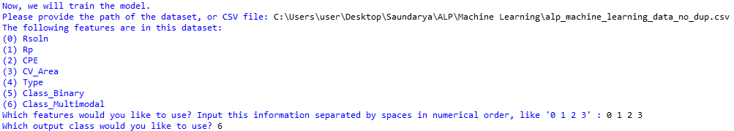

1. After doing so, the program should complete running. You should see the accuracy of the model displayed in the IDLE window, and a confusion matrix should appear on a separate window.



